1. 
2. **Agenda**:
   1. We will see the purpose of branches and actually the reason of using branches.
3. But before that, let us recap what is actually branch.
4. 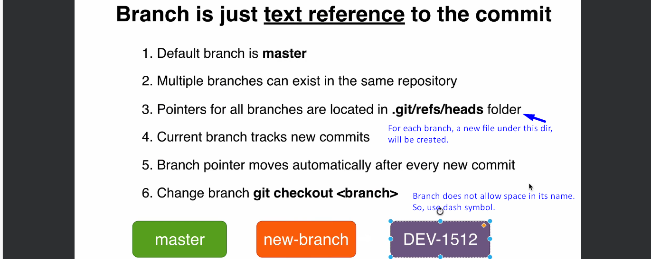
5. See the following is the picture of our Git Repo along with timeline.  
   A diagram of a process

   Description automatically generated
6. Suppose you want to implement some feature when you are on the second commit but not on main project branch master.  
   Here you decide to create a new branch BR-102.  
   So, from now on all the commits will be made on the BR-102 branch and master branch remain intact.  
   Now, we have two branches master and BR-102 and two developers can work on their respective branch independently.  
   **NOTE**: Branches do not know about other branches’ existence as branch is just a wrapper around a specific commit. That is all.
7. Every branch is a sperate history of our project.
8. So, if multiple developers are working on same project, they can work on a separate branch independently to do their job.  
   When the feature branch is done, we can merge that feature branch into master branch.
9. Every branch is a separate history line or a separate story.
10. **Summary**:
    1. Every branch is a separate story of our project.
    2. Commits can be made in different branches in parallel.
    3. Branches greatly simplify the collaboration process.